|  |  |
| --- | --- |
|  | FPT ACADEMY INTERNATIONAL  FPT – APTECH COMPUTER EDUCATION |

Center Name: ACE-HCMC-2-FPT

Address: 590 Cach Mang Thang Tam Street, District 3, Ho Chi Minh City, Viet Nam



Online Help Desk

Design Document

|  |  |  |  |
| --- | --- | --- | --- |
| Faculty: | | Mr. Tran Phuoc Sinh |  |
| Batch No: | | T11708A0 |  |
| Group No: | | 07 |  |
| Student: |  | Full Name | Roll No. |
|  | 1. | NGUYEN HOANG TU | STUDENT1054235 |
|  | 2. | NGUYEN THANH NAM | STUDENT1057514 |
|  | 3. | TRAN VAN THANG | STUDENT1053909 |

October, 2018

Mr. Nguyen Hoang Tu

Mr. Nguyen Thanh Nam

Mr. Tran Van Thang



This is to certify that

have successfully designed and

developed 

Submitted by:

Date of Issue: ________

Authorized Signature: ___________



# Table of Contents

Table of Contents 2

I. Acknowledgments 4

II. Problem Definition 5

1. Introduction 5

2. Existing Scenario 5

3. Requirement Specification 6

1.1. Administrator 6

1.2. Facility Heads (Users) 6

1.3. Assignees (Users) 6

1.4. Students (Users) 7

4. Hardware / Software Requirements 7

III. Task sheet review 1 8

I. Architecture & Design of the Project 10

1. Presentation Tier: 11

2. Business Logic Tier: 11

3. Data Access Tier: 11

II. Algorithms - Data Flowchart: 11

1. Login process (Admin & users): 12

2. Log out process (Admin & users): 13

3. Create new user process (Admin only): 14

4. View list of user account process (Admin only): 15

REVIEW I

# **Acknowledgments**

We would like to acknowledge all those who have given support and help us make the project a success.

We wish to express our deep gratitude to all teachers who have been devoting their lives to teach us how to stand-alone and walk ahead.

We are grateful to our families as well as our friends who take care and encourage us even though we are successful or failed. They never leave us alone and always look forward to us when we are on any road of the life.

We are much thankful to the entire staff and chairpersons at the Head Office of FPT – Aptech Centre who have been organizing and looking after our studying course.

There are no words to show our appreciation for our teacher, Mr Tran Phuoc Sinh, who worked day by day to teach and guide us to complete this project.

Finally, we would like to offer many thanks to all our schoolfellows for their valuable suggestions.

We would like to thank sincerely!

Group 7 – FPT Aptech.

# **II. Problem Definition**

## 1. Introduction

Perfect Technological Innovation is one of the largest university of technology in the world. Its campus is very huge with many facilities. Therefore, students, staff and people who want to manage and use these facilities have a big difficulty. That leads to the urgent demand to build an application which helps them to feel convenient and comfortable in conducting these material bases.

## 2. Existing Scenario

This project is aimed at developing an Online Help Desk (OHD) for the facilities in the Perfect Technological Innovation’s campus. This is an Intranet based application that can be accessed throughout the campus. This system can be used to automate the workflow of service requests for the various facilities in the campus. This is one integrated system that covers different kinds of facilities like class-rooms, labs, hostels, mess, canteen, gymnasium, computer centre, faculty club etc. Registered users (students, faculty, lab-assistants and others) will be able to log in a request for service for any of the supported facilities. These requests will be sent to the concerned people, who are also valid users of the system, to get them resolved. There are features like email notifications/reminders, addition of a new facility to the system, report generators etc in this system.

## 3. Requirement Specification

### Administrator

Administrator will have managing abilities:

* Manage user accounts (creating new user account, editing user info, blocking user on accessing this application, supporting in restoring password etc).
* Manage facilities (adding new facilities, deleting/block facilities).

### Facility Heads (Users)

Facility heads will have abilities:

* Login to the system through the first page of the application.
* Manage their information (Update their info and change password).
* See the list of the requests created by students.
* Send these requests to assignees who have responsibility to handle them.
* See the list of requests (both open and closed) sent by him/her to assignees over the past.
* Get help about Online Help Desk (OHD) System on how to use the different features of the system.

### Assignees (Users)

Assignees will have abilities:

* Login to the system through the first page of the application.
* Manage their information (Update their info and change password).
* View the requests sent from facility heads.
* Change the status of the request (work in progress, close or reject)
* See the list of requests sent to them.
* Get help about Online Help Desk (OHD) System on how to use the different features of the system.

### Students (Users)

Students have abilities:

* Login to the system through the first page of the application.
* Manage their information (Update their info and change password).
* Create a new request by specifying the facility, the severity of the request (there may be several levels of severity defined) and a brief description of the request
* See the status of the requests create by him/her (the status could be one of unassigned/assigned/work in progress/closed or rejected).
* Close a request created by him/her by giving an appropriate reason.
* Get help about Online Help Desk (OHD) System on how to use the different features of the system.

## 4. Hardware / Software Requirements

#### Software

|  |
| --- |
| * Visual Studio .Net / ASP * IIS server * .Net Framework * Java Virtual Machine/ J2EE server * Notepad/Java editor * j2sdk1.4.1_02 (or later). * EJB Dev Kit * Java enabled web server * JSP / Servlets Dev. Kit |

#### Hardware

|  |
| --- |
| * A minimum computer system that will help you access all the tools in the courses is a Pentium 166 or better * 128 Megabytes of RAM or better |

# **Task sheet review 1**

|  |  |  |  |  |  |
| --- | --- | --- | --- | --- | --- |
| Project Ref. No: 4 | Project Title:  Railway Reservation Manage System | Date of Preparation of Activity Plan | | | |
| No. | Task | Actual Start Date | Actual Days | Team Member Names | Status |
| 01 | Acknowledgment | Oct 24,2018 | 2 | All Members | Completed |
| 02 | Problem Definition | All Members | Completed |
| 03 | Customer Requirement | All Members | Completed |
| 05 | Hardware/Software | All Members | Completed |
| 06 | Task sheet | All Members | Completed |

|  |  |  |
| --- | --- | --- |
|  | Prepare By: Group 7 | Approved By: Faculty |
| Date: Oct 26, 2018 | Team Leader  Nguyen Hoang Tu | Tran Phuoc Sinh |

REVIEW II

# **Architecture & Design of the Project**

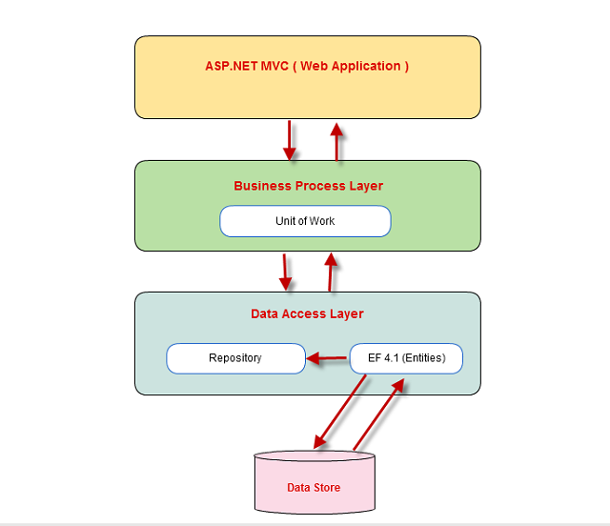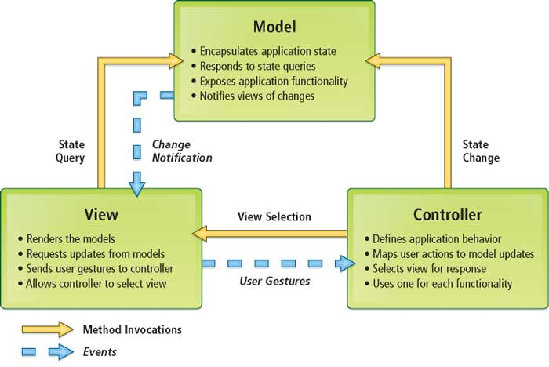

## Presentation Tier:

Is the tier in which the users interact with application . Presentation Tier contents Model, View, Controller used to receive a request and response to User.

Technology: ASP.NET MVC4, Razor, HTML, CSS, JavaScript, Ajax, JQUERY, Twitter Bootstrap

## Business Logic Tier:

Is mainly working as the bridge between Data Tier and Presentation Tier. All the Data passes through the Business Tier before passing to the Presentation Tier.

Technology: OOP, ASP.NET

## Data Access Tier:

Is basically the server which stores all the application’s data .Data tier contents Database Tables, Database Views and other means of storing Application Data .

Technology: SQL Server, LINQ, ADO.NET

# Algorithms - Data Flowchart:

Symbol generates:



## Login process (Admin & users):

Start

Login

User ID

Password

success

failure

Show fail message

Logged in

End

Validate

## Log out process (Admin & users):

Start

Logout

Confirm

yes

Clear Session

no

Login screen

End

## Create new user process (Admin only):

End

Data

base

User management

Start

Create new user account

failure

Input information

save

success

Generate and encode default password

Validate

## View list of user account process (Admin only):

User management

View list of users

Start

End

## “Change status of user” process (View specific user information, block, unblock, delete, reset password - Admin only):

View list of users

User management

Start

Search specific user

Unblock user

Reset password

Delete user

Block user

View user details

Validate

fail

success

Data

base

End